**Component decorative tags**

**Problem statement:** By default div tag wrapper is getting added to the component with class name same as that of component.

Ex: If component name is “sightly-comp”, a wrapper div tag is getting added with class name “sightly-comp”.

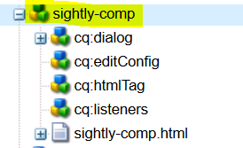

Wrapper div:

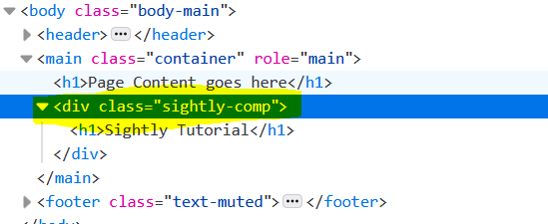

To remove this auto added div wrapper and to add our required html tags, follow the below mentioned steps.

**Removing auto generated/added div wrapper.**

On component node, add a property named “cq:noDecoration” of type Boolean and value as true.

So that by default not decoration tag will be added.

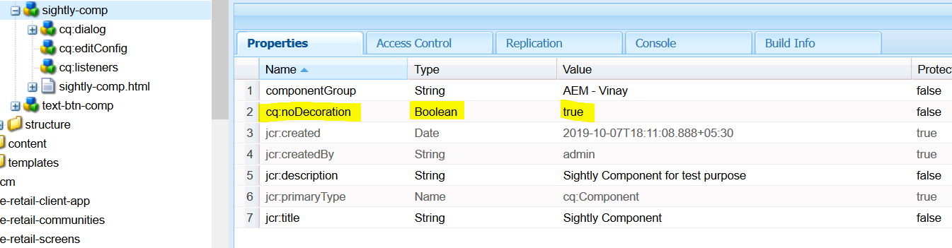

Result:

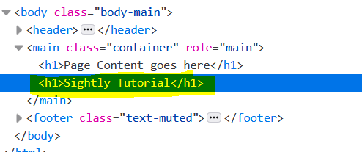

**Adding a new HTML tag and custom classes**

* Create a node with name “cq:htmlTag” of type “nt:unstructured”
* Add property named “cq:tagName” and value as required (Ex: section).
* Add property named “class” and value as required (Ex: sightly-custom-cls)

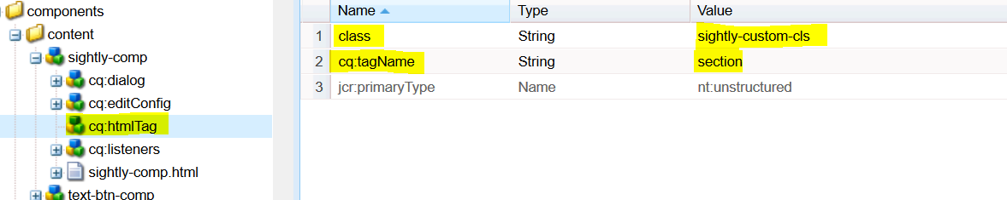

**Note:** Make sure to change the cq:noDecoration value to false (which is added on the component node).

If the cq:noDecoration value is true, then it will not let the new wrapper to add.

Result :

